 | SAKRMANNINGAGENCY  FORRECRUITINGEGYPTIANLABORABROAD | IssueDate | 15.05.2022
 |  | RevisionDate | 27.05.2023
 | CrewingManagementManual  SeafarerEmploymentApplication | Revision | 1.2
 |  | Page | 3

ApplicationForPositionas |  |  |  |  | ASST.Plumber |  |  |  |  |  |  |  |  |  |  | 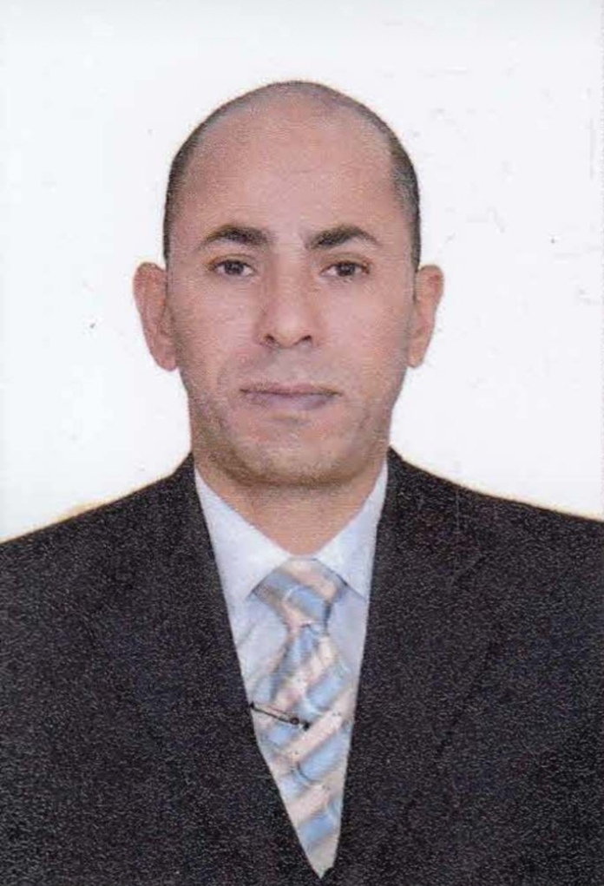
RegisterCode. |  |  |  |  | DR-10.007
OtherPosition(IfAny)
RegisterDate |  |  |  |  | 25/12/2023
LastupDateData
ExpectedSalary
1.PERSONALDETAILS
FullName |  | MOHAMED ABD ELRAHIM SELIM
DateOfBirth |  | 1976/6/16 |  |  |  |  |  |  | PlaceOfBirth |  |  |  |  |  | Assiout
Nationality |  | Egyptian |  |  |  |  |  |  | MaritalStatus |  |  |  |  |  | Single |  |  |  |  |  |  | Married √
Height(Cm) |  | 170 |  |  |  |  |  |  | OverallSize |  |  |  |  |  | xXL |  |  |  |  | ShirtSize |  |  |  | XxL
Weight(Kg) |  | 73 |  |  |  |  |  |  | TrouserSize |  |  |  |  |  | 40 |  |  |  |  | ShoesSize |  |  |  | 43
2.EDUCATION
College/School |  | Bachelor in Art with open learning System, Cairo University
MarlineTest |  | IssuedDate |  |  |  |  | Result% |  |  |  | IssuedBy(Authority) |  |  |  |  |  |  |  | IssuedAt
EnglishLanguage |  | Fluent |  |  |  |  |  | Good √ |  |  |  |  | Average |  |  |  |  |  | Poor
……Arabic…Language |  | Fluent ✅ |  |  |  |  |  | Good |  |  |  |  | Average |  |  |  |  |  | Poor
3.CONTACT DETAILS
HomeAddress/City |  | Bawit Village, Dayrut, Assiut, Egypt
E-Mail |  | mohameawadalla202@gmail.com |  |  |  |  |  |  |  | Mobile/Tel |  |  |  | +201270961626
4.TRAVELDOCUMENTS
Type |  | DocumentNo. |  |  |  | ISS.Date |  |  | Exp.Date |  |  |  |  | ISS.By(Authority) |  |  |  |  |  |  |  | PlaceofIssue
Passport |  | A33925110 |  |  |  | 2023/5/25 |  |  | 24/08/2030 |  |  |  |  | Egyptian Authority |  |  |  |  |  |  |  | Assiout
SeamanBook |  | S00034078 |  |  |  | 2023/8/27 |  |  | 22/08/2028 |  |  |  |  | EAMS |  |  |  |  |  |  |  | Alex.
OtherSeamanBook
5.PROFESSIONALQUALIFICATION/CERTIFICATEOFCOMPETENCY
CertificateName |  |  |  | Number |  | IssueDate |  |  |  |  |  | ExpiryDate |  |  |  | IssuedBy |  |  |  |  |  |  | IssuedAt
COC(Rank)………….. |  |  |  |  |  |  |  |  |  |  |  |  |  |  |  | EAMS |  |  |  |  |  |  | Alex.
GOC |  |  |  |  |  |  |  |  |  |  |  |  |  |  |  | NTRA |  |  |  |  |  |  | Cairo
D.P.INDUCTION
D.P.ADVANCED
D.P.OPERATOR(UNLIMITED)
6. NEXTOFKIN
FullName | Shawky Zakaria Abd ElAleem |  |  |  |  |  |  |  |  |  |  |  |  | Relationship |  |  |  | Cousin
Address | Bawit Village, Dayrut, Assiut
Tel.No. |  |  |  |  |  |  |  |  |  | Mobile |  |  |  |  |  |  |  |  |  |  | +201009608839
7.HEALTHCERTIFICATES&VACCINATIONS
FlagState |  |  | Number |  |  |  | IssueDate |  |  |  |  | ExpiryDate |  |  |  |  | IssuedBy |  |  |  |  |  | IssuedAt
InternationalMedical |  |  |  |  |  |  | 3/09/2023 |  |  |  |  | 2/09/2025 |  |  |  |  | EAMS |  |  |  |  |  | Alex.
YellowFever |  |  |  |  |  |  | 4/09/2023 |  |  |  |  | Valid for life long |  |  |  |  | Ministryof Health |  |  |  |  |  | Alex
Cholera |  |  |  |  |  |  |  |  |  |  |  |  |  |  |  |  | Ministryof Health
Covid-19 |  |  | VaccinationName |  |  |  | FirstDose |  |  |  |  | SecondDose |  |  |  |  | (OtherDoesorRemarks)
 |  |  | pfizer |  |  |  | 2021/12/13 |  |  |  |  | 2022/1/26

8.MARINECOURSES
CourseName |  | Number | IssueDate | ExpiryDate | IssuedBy/At
PersonalSurvivalTechniques |  | XNPST2630 | 2023/9/25 | 2028/9/18 | Alex
AdvancedFirePreventionandFireFighting |  | XNFF2220 | 2023/9/25 | 2028/9/18 | Alex
ElementaryFirstAid |  | XNFA2619 | 2023/9/23 | 2028/9/16 | Alex
MedicalCareStudies
PersonalSafetyandSocialResponsibilities |  | XNPS2732 | 2023/9/23 | 2024/12/2 | Alex
ProficiencyOfSecurityAwareness TrainingSeafarers |  | XNA4593 | 2023/10/1 | 2028/9/19 | Alex
Proficiencyasaship Securityofficer(PSSO)
ProficiencyInSurvival Craft&RescueBoats |  |  |  |  | Alex
G.M.D.S.S
Communications
AdvancedCommunications
ECDISAdvancedSimulator(ManagementLevel)
ECDISSimulator(OperationLevel)
PreventionandCombatingofMarinePollution
Radar&ARPASimulatorandSearch&rescue ARPA Simulator and Search
MarineRadarandautomaticRadarPlotting
BridgeresourceManagement (B.R.M)
Engineresource Management (E.R.M)
NavigationalWatchkeeping
ProficiencyforRatingformingpartofNavigationalwatch(II/4)
Highvoltagetraining–operationofship(1000VoltandMore)
PassengerSafetyCargoSafetyandHullintegrity
CrowdManagementTraining
CrisisManagementandHumanBehaviorTraining
SafetytrainingforPersonalProv.DirectPassengers
PracticalAbilityto PrepareMealsand | (MLC2006)
PersonalHygieneandEnvir.Protection | (MLC2006)
Safetyand Healthin theProvision Meals | (MLC2006)
FoodStorageandinventoryControl | (MLC2006)
ShipsCookCertificate | (MLC2006)
AbelSeafarerDeck
ProficiencyforAbelSeafarerDeck | (II/5)
EngineeringWatchkeeping
ProficiencyforRatingformingpartofawatchinengine room
AbelSeafarerEngine
ProficiencyforAbelSeafarerEngine | (III/5)
ElectroTechnicalRating
ProficiencyforElectroTechnicalrating | (III/7)
ProficiencyinSurvival CraftsandRescueBoats

 | COMPLETESEA–SERVICEDETAILS
Name: |  |  |  |  | Rank: |  | RegisterCode:
CompanyName |  | Rank | VesselName | Flag | SignedOn | SignedOff | Period | VesselType | D.W.T. | EngineType | BH | KW
 |  | Asst. PLUMBER | ANTAREST | LIBERIA | 2021/2/5 | 2021/12/20 |  | PASSENGERS
 |  | ASST PLUMBER | ANGELO STERN | ITALY | 2022/1/15 | 2022/10/25 |  | PASSENGERS
Elreedy Shiping |  | Water and pool Opration | M/V LINDA CEM | PANAMA | 2022/11/21 | 2023/9/22 |  | Bulk Carrier | 34196

 | SPECIALISEDEXPERIENCE
 | Name |  |  |  |  | Type |  | From |  |  | To |  | Comments
I declarethat theinformation Ihavegiven is, tothebest ofmyknowledge, true andcomplete. I alsodeclarethat thedocumentssubmitted aregenuine,given and signby persons

DATE : 13/12/2023 Signature : Mohamed Abdel

Rahim Selim

